Image | 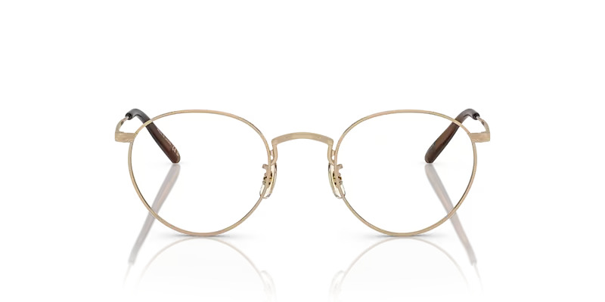
Brand | DIOR
Model Name | OP 47
Price | RS 1200
PRODUCT DETAILS

